INTRODUCTION

The HTTP - Hypertext Transfer Protocol is a widely used protocol said to be the foundation of data communication for the World Wide Web. HTTP (Hypertext Transfer Protocol) is a set of rules that runs on top of the TCP/IP suite of protocols and defines how files are to be transferred between clients and servers on the world wide web. It is based on the Client/Server model.

HTTP/1.1 is the first standardised version of HTTP introduced in 1997. It presented significant performance optimizations over previous versions(HTTP/0.9) and HTTP/1.0) and transformed the way requests and responses were exchanged between clients and servers.

HTTP/2 was introduced in 2015 based on Google's experimental protocol SPDY.It supports all the core features of the HTTP/1.1 but aims to be more efficient, like - support for multiplexing and server push. Therefore, HTTP/2 is much faster and more reliable than HTTP/1.1.

THE KEY DIFFERENCES BETWEEN HTTP1.1 AND HTTP2

HTTP/1.1 | HTTP/2
- Http1.1 supports connection reuse i.e. for every TCP connection there could be multiple requests and responses, and pipelining where the client can request several resources from the server at once. However, pipelining was hard to implement due to issues such as head-of-line blocking and was not a feasible solution | - Http2 uses multiplexing, where over a single TCP connection resources to be delivered are interleaved and arrive at the client almost at the same time. It is done using streams which can be prioritised, can have dependencies and individual flow control. It also provides a feature called server push that allows the server to send data that the client will need but has not yet requested.
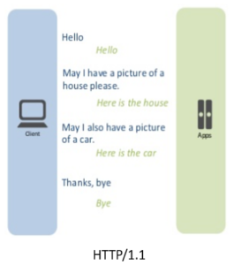 | 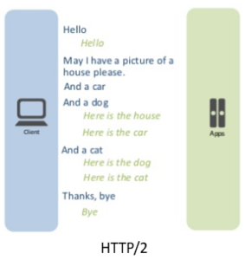
- Http1.1 introduces a warning header field to carry additional information about the status of a message. Can define 24 status codes, error reporting is quicker and more efficient. | - In Http2 underlying semantics of HTTP such as headers, status codes remains the same.
- Http1 is relatively secure since it uses digest authentication, NTLM authentication. | - In Http2 security concerns from previous versions will continue to be seen in HTTP/2. However, it is better equipped to deal with them due to new TLS features like connection error of type Inadequate_Security.
- Http1 expands on the caching support by using additional headers like cache-control, conditional headers like If-Match and by using entity tags. | - HTTP/2 does not change much in terms of caching. With the server push feature if the client finds the resources are already present in the cache, it can cancel the pushed stream.
- HTTP/1.1 provides faster delivery of web pages and reduces web traffic as compared to HTTP/1.0. However, TCP starts slowly and with domain sharding (resources can be downloaded simultaneously by using multiple domains), connection reuse and pipelining, there is an increased risk of network congestion. | - HTTP/2 utilises multiplexing and server push to effectively reduce the page load time by a greater margin along with being less sensitive to network delays.

So , another words following are the advantages of HTTP/1.1 over HTTP/2
- Reduce latency by avoiding less requests. Through 1)head-of-line-blocking.
2)Prioritisation of Requests.
3) Maintaining fewer TCP connections.
- Header file compression - HPACK which avoids maintaining a list of headers (which are mostly verbose and cause unnecessary traffic) used in previous requests.
- Binary Message Framing - enables efficient processing of messages .
- Server Push - where server sends data which it anticipates that the client needs before the client requests it.
- Compatibility - HTTP2 can work with clients/servers running on HTTP/1.1 as it is based on same protocol.

So currently, As the web pages are more complex and require large bandwidth to work http2 becomes an increasingly adopting protocol over http1.1. Most modern browsers today support HTTP2 whereas several companies have already moved their servers to http2 protocol.

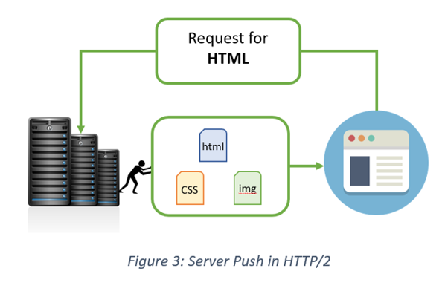
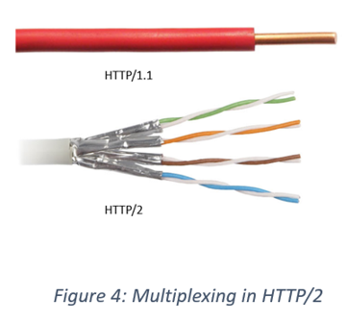

REFERENCES :
- https://datatracker.ietf.org/doc/html/rfc7540
- https://factoryhr.medium.com/http-2-the-difference-between-http-1-1-benefits-and-how-to-use-it-38094fa0e95b
- https://developer.mozilla.org/en-US/docs/Web/HTTP/Basics_of_HTTP/Evolution_of_HTTP
- https://cheapsslsecurity.com/p/http2-vs-http1/#:~:text=HTTP2%20is%20much%20faster%20and,then%20the%20page%20loads%20faster.

